POOL RULES
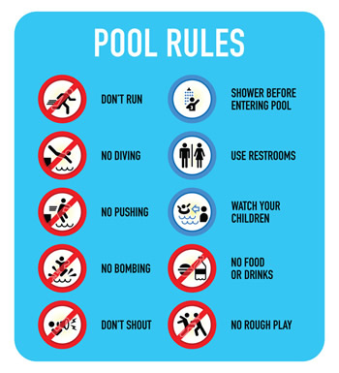
Don’t run Watch your children at all times
No Diving (pool is only 1.3m deep) Shower before entering the pool
No Pushing Use W/C, don’t use pool
No dive bombing No rough play
Keep noise down (no personal music) Children not potty trained must wear diapers
No food or drink in pool(no glass in pool area) Life vests available if needed
PHOU KHMER CANNOT BE HELD ACCOUNTABLE FOR LOSS, DAMAGE OR INJURY TO YOUR PROPERTY, YOU or your FAMILY. BE SAFE and follow the RULES!!!

